Practical – 3
Responsive UI Design using CSS Grid, Flexbox, and Bootstrap/Tailwind
Problem Definition
Design responsive layouts for Home, About, Registration, Dashboard, and Events pages using CSS Grid and Flexbox. Optionally use a CSS framework such as Bootstrap or Tailwind. Ensure mobile-first responsiveness.
A. Theory
1. How does the layout adapt for mobile, tablet, and desktop screens?
Answer: The design follows a mobile-first approach. On mobile, content is arranged mainly in one column. On tablets, cards can appear in two columns. On desktop, wider layouts and three-column card grids can be used. Media queries apply styles at different viewport widths.
2. Which layout technique is used and why?
Answer: Flexbox is used for one-dimensional layouts such as navigation bars and button rows. CSS Grid is used for two-dimensional layouts such as dashboard panels and event cards. Both can be combined.
3. Are typography, spacing, colors, and contrast readable?
Answer: Use readable font sizes, consistent spacing, a limited color palette, and sufficient text/background contrast. Test the interface at different screen sizes and keep keyboard focus visible.
4. Is the framework used consistently without unnecessary inline CSS?
Answer: If Bootstrap or Tailwind is selected, use its classes consistently. Keep custom rules in a shared CSS file and avoid unnecessary inline style attributes. This example uses plain CSS, Grid, and Flexbox.
5. What is responsive web design?
Answer: Responsive web design allows a website to adapt to different screen sizes and devices using flexible layouts, media queries, and responsive sizing.
6. What is a CSS media query?
Answer: A media query applies CSS when a condition is met, such as a minimum viewport width. For example, @media (min-width: 768px) can change a one-column layout to two columns.
7. What is the difference between Grid and Flexbox?
Answer: Grid is mainly for two-dimensional layouts with rows and columns. Flexbox is mainly for arranging items in one direction, either a row or a column.
8. What is mobile-first design?
Answer: Mobile-first design starts with styles for small screens, then adds enhancements for larger screens using media queries.
9. What is Bootstrap?
Answer: Bootstrap is a front-end framework that provides a responsive grid, utility classes, and reusable interface components.
10. Why should all StudentHub pages have a consistent design?
Answer: Consistent colors, typography, navigation, buttons, and spacing make the site easier to use and create a unified appearance.
B. Implementation / Output / Result
Create the following files. This sample uses plain CSS with Grid and Flexbox, so a CSS framework is optional.
1. Project folder structure
StudentHub/
├── index.html
├── about.html
├── register.html
├── dashboard.html
├── events.html
├── contact.html
├── feedback.html
└── css/
└── style.css
2. Shared CSS (save as css/style.css)
/* Mobile-first shared styles */
:root {
--primary: #174ea6;
--dark: #10233f;
--page-bg: #f4f7fb;
--surface: #ffffff;
--text: #1e293b;
--muted: #526174;
--border: #d8e0ea;
}
* { box-sizing: border-box; }
body {
margin: 0;
font-family: Arial, sans-serif;
line-height: 1.6;
color: var(--text);
background: var(--page-bg);
}
img { max-width: 100%; height: auto; }
.container { width: min(1100px, 92%); margin-inline: auto; }
.skip-link { position: absolute; left: -9999px; top: 0; background: white; padding: .75rem; }
.skip-link:focus { left: .5rem; z-index: 10; }
.site-header { background: var(--primary); color: white; padding: 1rem 0; }
.header-row { display: flex; flex-direction: column; gap: .75rem; }
.brand { margin: 0; font-size: 1.5rem; }
.nav-list { display: flex; flex-wrap: wrap; gap: .5rem 1rem; list-style: none; margin: 0; padding: 0; }
.nav-list a { color: white; text-decoration: none; }
.nav-list a:hover, .nav-list a:focus { text-decoration: underline; }
main { padding: 1.5rem 0 2rem; }
.hero, .card, .panel { background: var(--surface); border: 1px solid var(--border); border-radius: .75rem; padding: 1.25rem; }
.hero { margin-bottom: 1.25rem; }
h1, h2, h3 { line-height: 1.25; }
h1 { font-size: clamp(1.7rem, 4vw, 2.5rem); }
h2 { font-size: clamp(1.25rem, 3vw, 1.7rem); }
.muted { color: var(--muted); }
.card-grid { display: grid; grid-template-columns: 1fr; gap: 1rem; }
.flex-row { display: flex; flex-wrap: wrap; gap: .75rem; align-items: center; }
.button { display: inline-block; padding: .65rem 1rem; border-radius: .4rem; border: 1px solid var(--primary); background: var(--primary); color: white; text-decoration: none; cursor: pointer; }
.button.secondary { background: white; color: var(--primary); }
form { display: grid; gap: 1rem; max-width: 600px; }
label { display: block; font-weight: bold; margin-bottom: .25rem; }
input, textarea, select { width: 100%; padding: .7rem; border: 1px solid #7b8796; border-radius: .35rem; font: inherit; background: white; }
:focus-visible { outline: 3px solid #f5b700; outline-offset: 2px; }
.site-footer { background: var(--dark); color: white; padding: 1rem 0; margin-top: 1rem; }
/* Tablet */
@media (min-width: 600px) {
.header-row { flex-direction: row; justify-content: space-between; align-items: center; }
.card-grid { grid-template-columns: repeat(2, minmax(0, 1fr)); }
main { padding-top: 2rem; }
}
/* Desktop */
@media (min-width: 900px) {
.card-grid { grid-template-columns: repeat(3, minmax(0, 1fr)); }
.hero { padding: 2rem; }
}
3. Home page (save as index.html)
<!DOCTYPE html>
<html lang="en">
<head>
<meta charset="UTF-8">
<meta name="viewport" content="width=device-width, initial-scale=1.0">
<title>StudentHub | Home</title>
<link rel="stylesheet" href="css/style.css">
</head>
<body>
<a class="skip-link" href="#main-content">Skip to main content</a>
<header class="site-header">
<div class="container header-row">
<p class="brand"><strong>StudentHub</strong></p>
<nav aria-label="Main navigation">
<ul class="nav-list">
<li><a href="index.html" aria-current="page">Home</a></li>
<li><a href="about.html">About</a></li>
<li><a href="register.html">Register</a></li>
<li><a href="dashboard.html">Dashboard</a></li>
<li><a href="events.html">Events</a></li>
<li><a href="contact.html">Contact</a></li>
<li><a href="feedback.html">Feedback</a></li>
</ul>
</nav>
</div>
</header>
<main id="main-content" class="container">
<section class="hero">
<p class="muted">Your campus, organized</p>
<h1>Welcome to StudentHub</h1>
<p>Access academic updates, student services, campus events, and useful links in one place.</p>
<div class="flex-row">
<a class="button" href="dashboard.html">Open Dashboard</a>
<a class="button secondary" href="events.html">Explore Events</a>
</div>
</section>
<section aria-labelledby="features-title">
<h2 id="features-title">Explore StudentHub</h2>
<div class="card-grid">
<article class="card"><h3>Academic Dashboard</h3><p>Review academic summaries and important reminders.</p><a href="dashboard.html">View dashboard</a></article>
<article class="card"><h3>Campus Events</h3><p>Find workshops and student activities.</p><a href="events.html">View events</a></article>
<article class="card"><h3>Student Profile</h3><p>Keep student information organized.</p><a href="register.html">Get started</a></article>
</div>
</section>
</main>
<footer class="site-footer"><div class="container"><p>&copy; 2026 StudentHub | Student Portal UI Demonstration</p></div></footer>
</body>
</html>
4. Content plan for remaining pages
about.html — About StudentHub
Describe the portal's purpose, goals, and available student services. Use a hero panel and feature cards.
register.html — Student Registration
Create labelled fields for full name, student email, student ID, and password. This is a static UI unless connected to a backend.
dashboard.html — Student Dashboard
Use responsive summary cards for Attendance, Assignments, Results, Timetable, and Notices.
events.html — Campus Events
Create event cards containing a title, date, description, and descriptive action link.
contact.html — Contact StudentHub
Intermediate extension: add a responsive form for name, email, subject, and message.
feedback.html — Feedback
Intermediate extension: add rating choices and a labelled feedback textarea.
5. Responsive registration form example
<section class="panel">
<h1>Student Registration</h1>
<p class="muted">Enter your details to create a student profile.</p>
<form action="#" method="post">
<div><label for="full-name">Full name</label>
<input id="full-name" name="full_name" type="text" autocomplete="name" required></div>
<div><label for="student-email">Student email</label>
<input id="student-email" name="email" type="email" autocomplete="email" required></div>
<div><label for="student-id">Student ID</label>
<input id="student-id" name="student_id" type="text" required></div>
<div><label for="password">Password</label>
<input id="password" name="password" type="password" autocomplete="new-password" required></div>
<button class="button" type="submit">Create Account</button>
</form>
</section>
Note: action="#" is only for demonstration. Real registration needs server-side validation and secure storage.
6. Implementation steps
1. Open the StudentHub folder in VS Code.
2. Create index.html, about.html, register.html, dashboard.html, and events.html. Add contact.html and feedback.html for the intermediate extension.
3. Create a css folder and save the stylesheet as css/style.css.
4. Link every page to the shared stylesheet using <link rel="stylesheet" href="css/style.css">.
5. Reuse the same header, navigation, main container, and footer on all pages.
6. Use Flexbox for navigation and button rows; use Grid for dashboard and event-card collections.
7. Write base styles for mobile, then use media queries at 600px and 900px for wider layouts.
8. Update each page's title, active navigation link, and main content. Confirm every href points to a real file.
9. Open the pages in a browser and test narrow mobile, tablet, and desktop widths using Developer Tools responsive mode.
10. Capture screenshots at all three sizes and insert them into the report.
C. Evidence of Work (Screenshots)
Insert screenshots of your actual running pages:

• Home page — desktop view
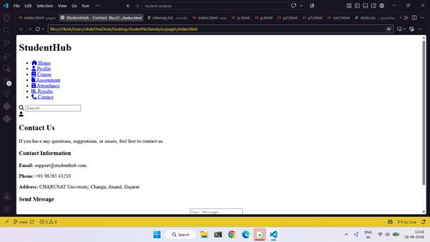
• Dashboard or Events page — desktop view
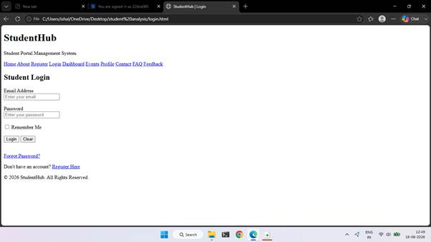
• Registration page — mobile view
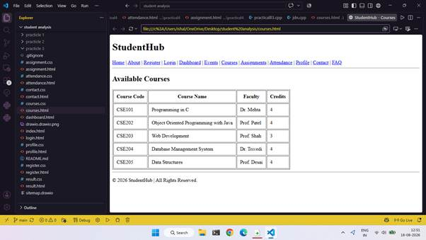
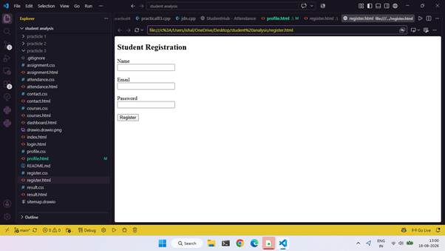
• VS Code project structure and shared CSS file
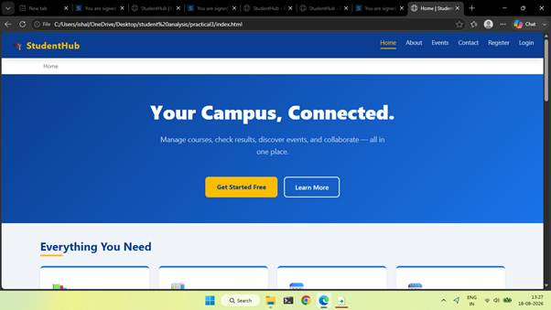
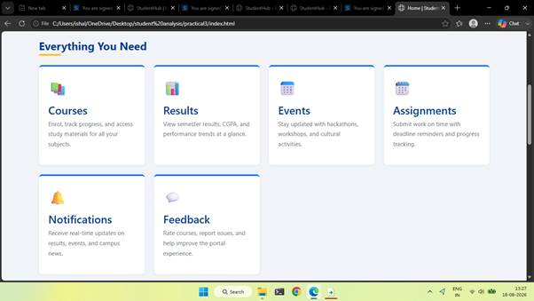
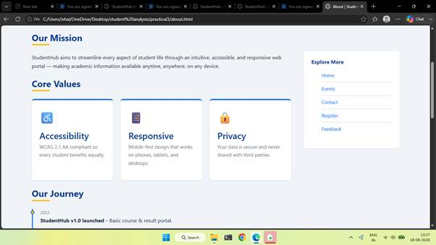
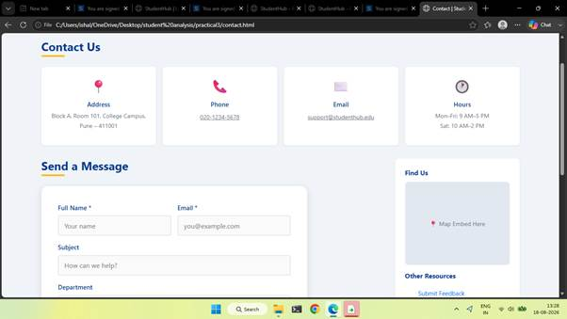
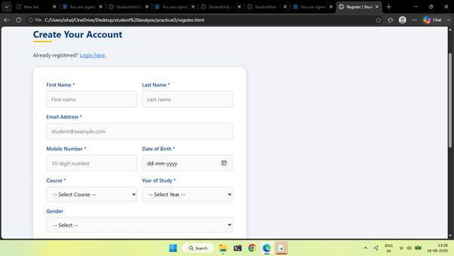
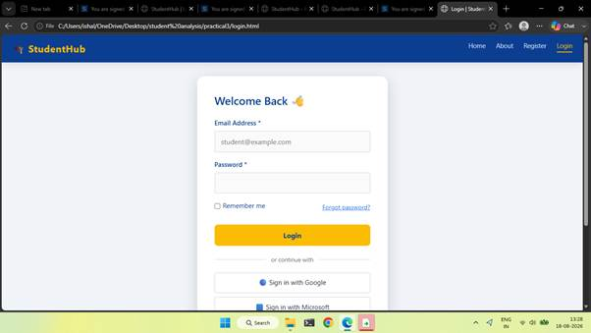
D. Responsive Design Checklist
☐ Viewport meta tag is included on every page.
☐ Pages are usable on mobile without unwanted horizontal scrolling.
☐ Navigation wraps or rearranges on small screens.
☐ Card grid shows one column on mobile, two on tablet, and three on desktop where suitable.
☐ Flexbox is used for one-dimensional alignment.
☐ CSS Grid is used for dashboard/card layouts.
☐ Text is readable and spacing is consistent.
☐ Interactive controls have sufficient contrast and visible keyboard focus.
☐ All pages use a shared stylesheet and consistent visual design.
☐ No unnecessary inline CSS is used.
☐ All navigation links work.
☐ Screenshots show mobile, tablet, and desktop layouts.
E. Challenges Faced
1. Choosing between Flexbox and Grid for different sections.
2. Adjusting layouts using media queries.
3. Maintaining consistent typography, colors, spacing, and navigation.
4. Testing pages at different viewport sizes and checking for horizontal overflow.
F. Learning Outcomes
1. Learned to create responsive layouts using CSS Grid and Flexbox.
2. Understood mobile-first design and media queries.
3. Created reusable styles in a shared CSS file.
4. Improved visual consistency across StudentHub pages.
5. Practised testing layouts using browser developer tools.
G. Viva Questions
What is responsive web design?
Answer: A design approach that adapts a website to different devices and screen sizes.
What is CSS Flexbox?
Answer: A one-dimensional layout system for arranging items in a row or column.
What is CSS Grid?
Answer: A two-dimensional layout system for rows and columns.
What is a media query?
Answer: A CSS rule that applies styles when a condition, such as viewport width, is met.
What does mobile-first mean?
Answer: Writing base styles for small screens first and enhancing them for larger screens.
Why use box-sizing: border-box?
Answer: It includes padding and borders within an element's declared width and height.
What is the viewport meta tag for?
Answer: It helps the browser match the page layout to the device viewport.
When should Grid be used instead of Flexbox?
Answer: Use Grid for two-dimensional layouts and Flexbox for one-dimensional alignment.
What is Bootstrap?
Answer: A front-end framework with a responsive grid, utility classes, and reusable components.
Why keep CSS in a separate file?
Answer: It improves reuse, readability, maintenance, and consistency.
How do you test responsiveness?
Answer: Use browser Developer Tools responsive mode and inspect mobile, tablet, and desktop sizes.
What is the difference between fixed and flexible widths?
Answer: Fixed widths stay constant; flexible widths adjust to the available space.
H. Result
Responsive StudentHub page layouts were planned using CSS Grid, Flexbox, and mobile-first media queries. Test each page at mobile, tablet, and desktop sizes and insert screenshots to demonstrate the actual result.
Faculty Remarks
(Keep this section blank for faculty.)

